Lab 2 placeholder- documentation

Task 1 –
We needed to take a screenshot of our ArchOSC assignment folder to show we was successfully able to create the file location for the project and to make a specific folder to document our work clearly.
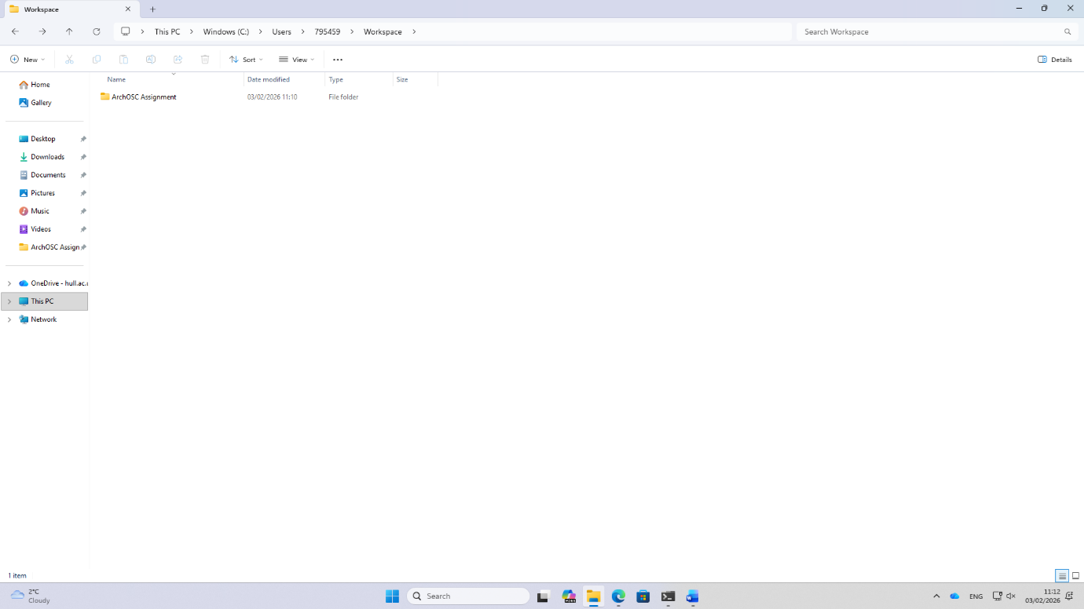
Task 2 – used the git init command in terminal to create a remote repository that we can link to our online repository later on.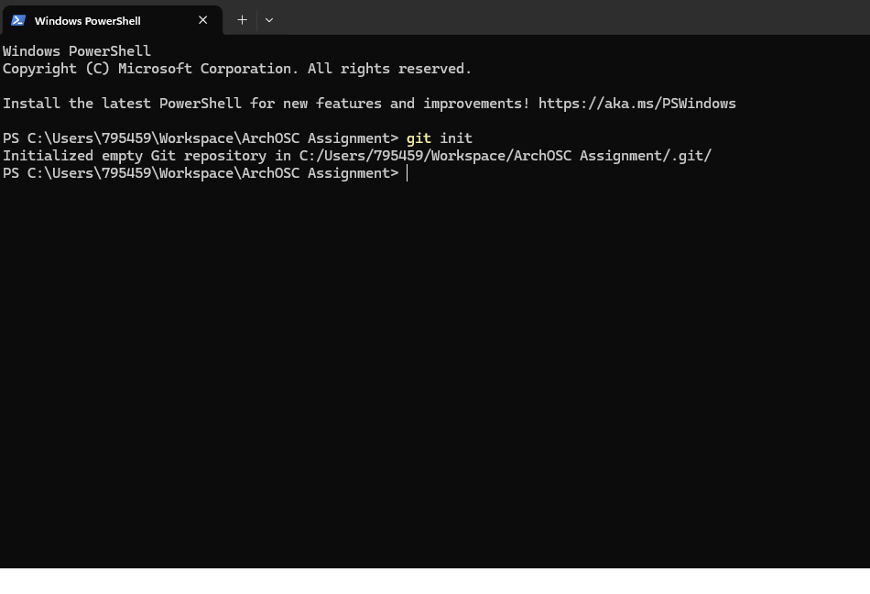

Task 3 – created an online repository that we can link our local repository too
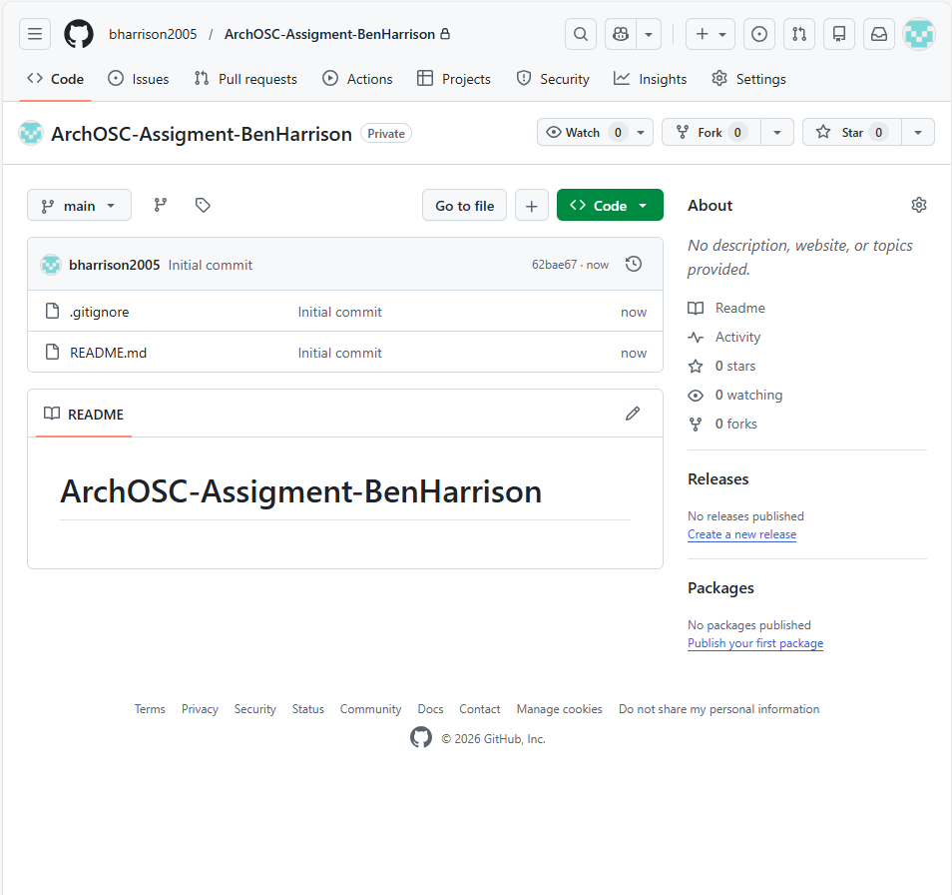

Task 4 – used the git remote pull origin main command to link the online repository to our local repository which allows us to push and pull changes creating a online backup/save of the work.
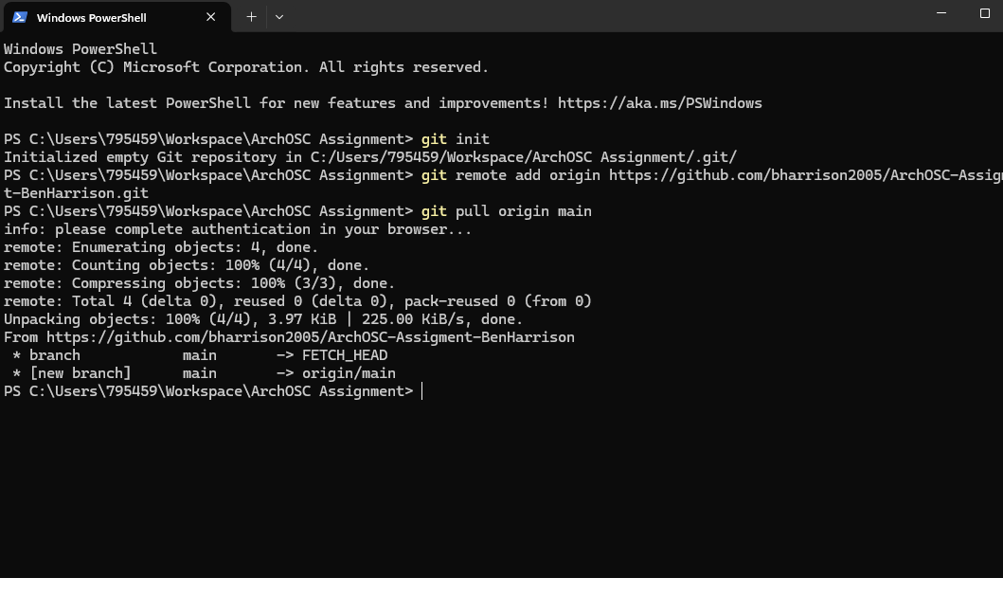

Task 5 – used the git pull and push commands to save changes and the git status and git commit to check file status and add notes of changes or work done.
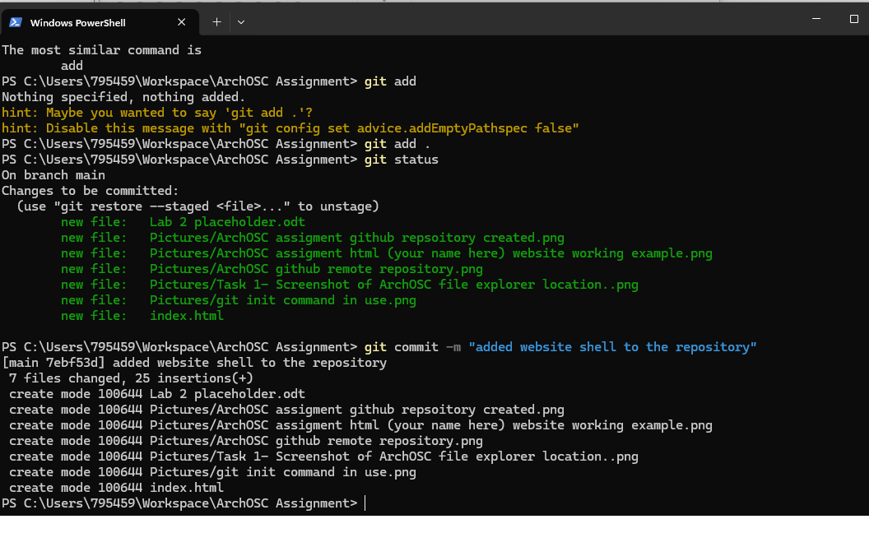

Task 5 – online repository updated showing all local files on GitHub page.
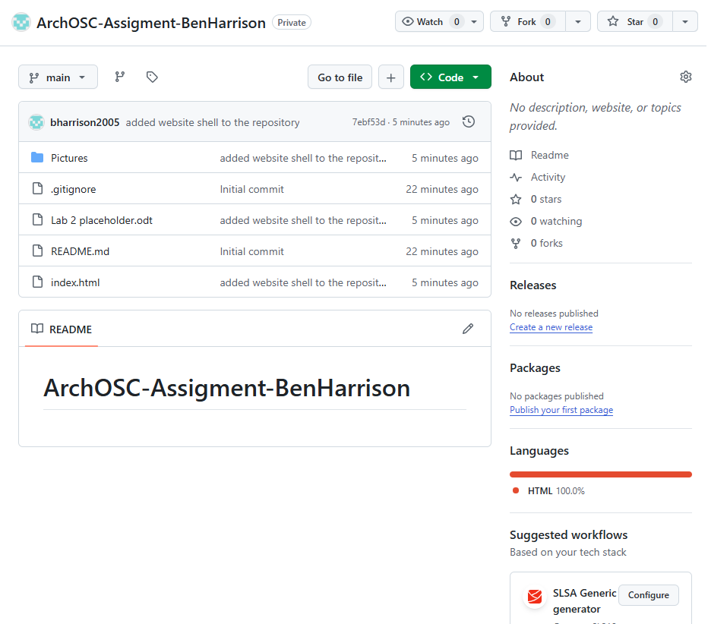

Task 6 – built and deployed website through GitHub pages creating a link to the page that can be shared and used to access webpage.
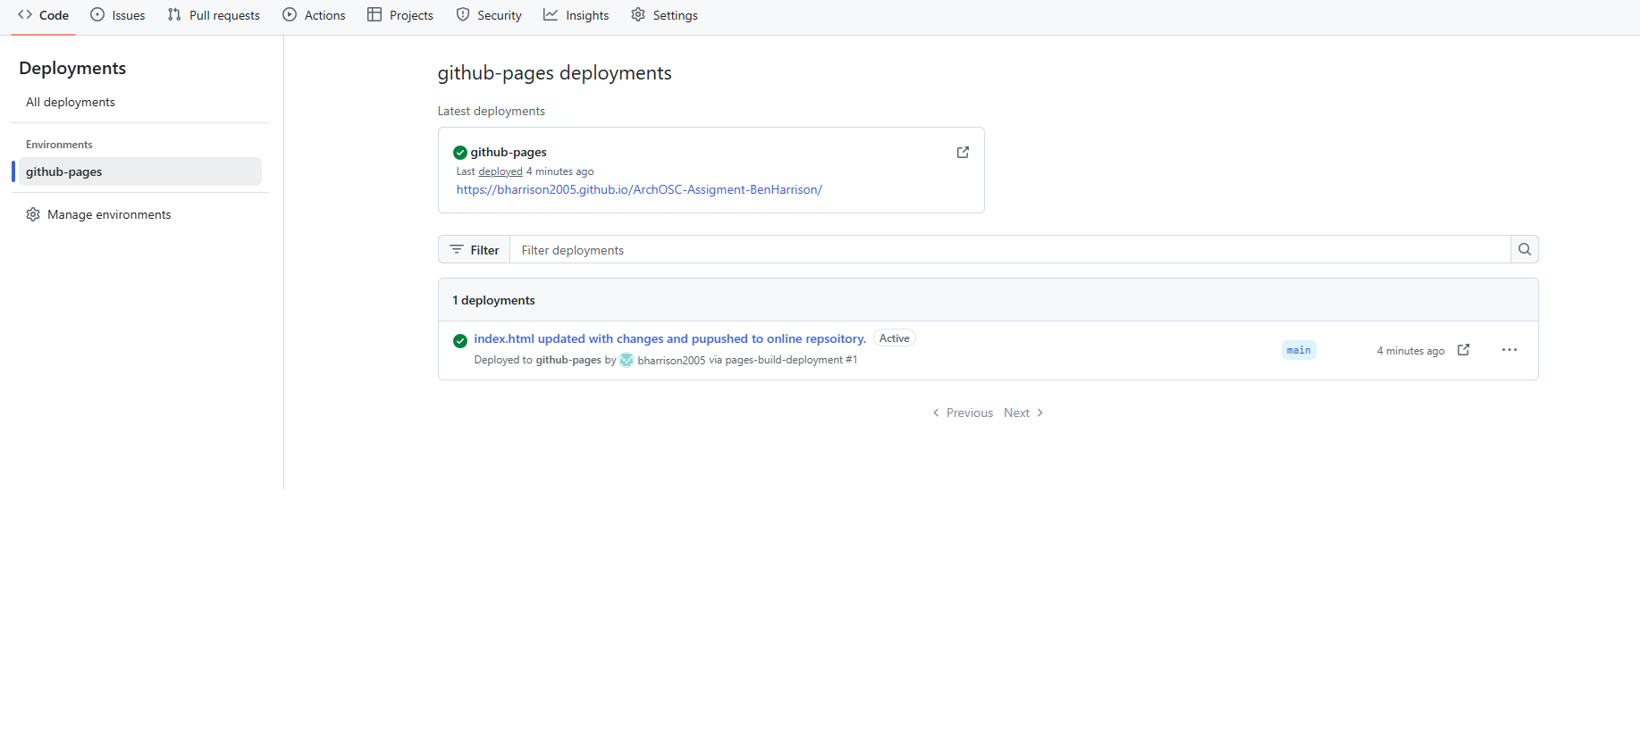
Task 6 – webpage example.
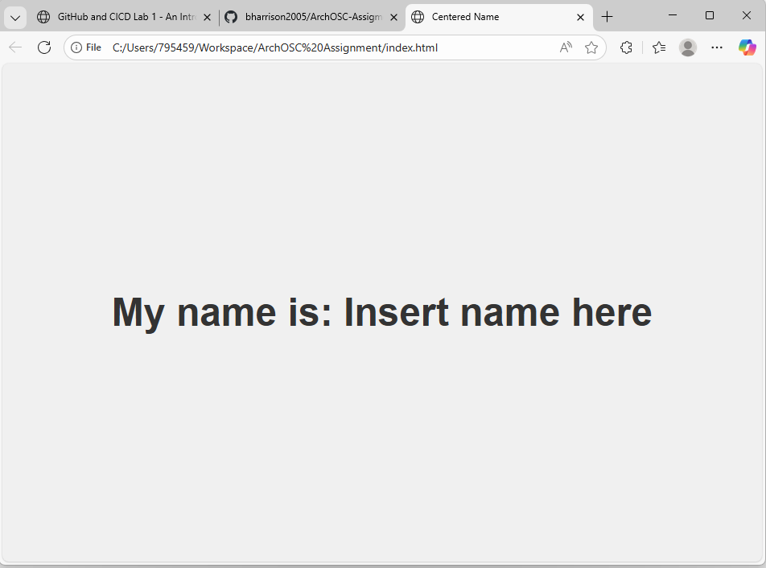

Task 6 – updated webpage.
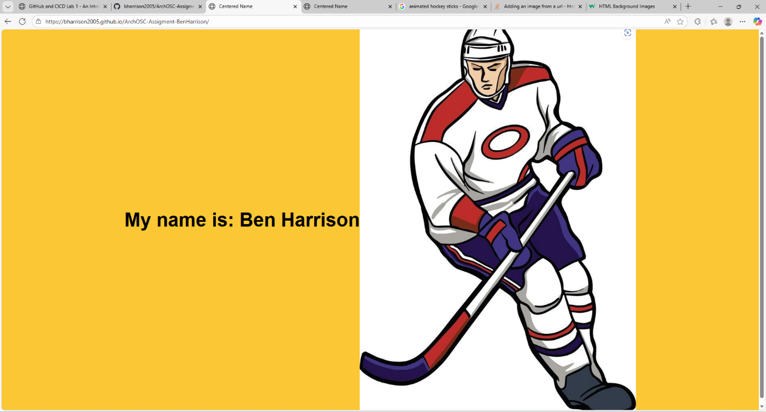

Task 7 – finished wepage.

